Subject: Win Wire: Bonafide Medical and Mission Cloud
AMAZON.COM CONFIDENTIAL
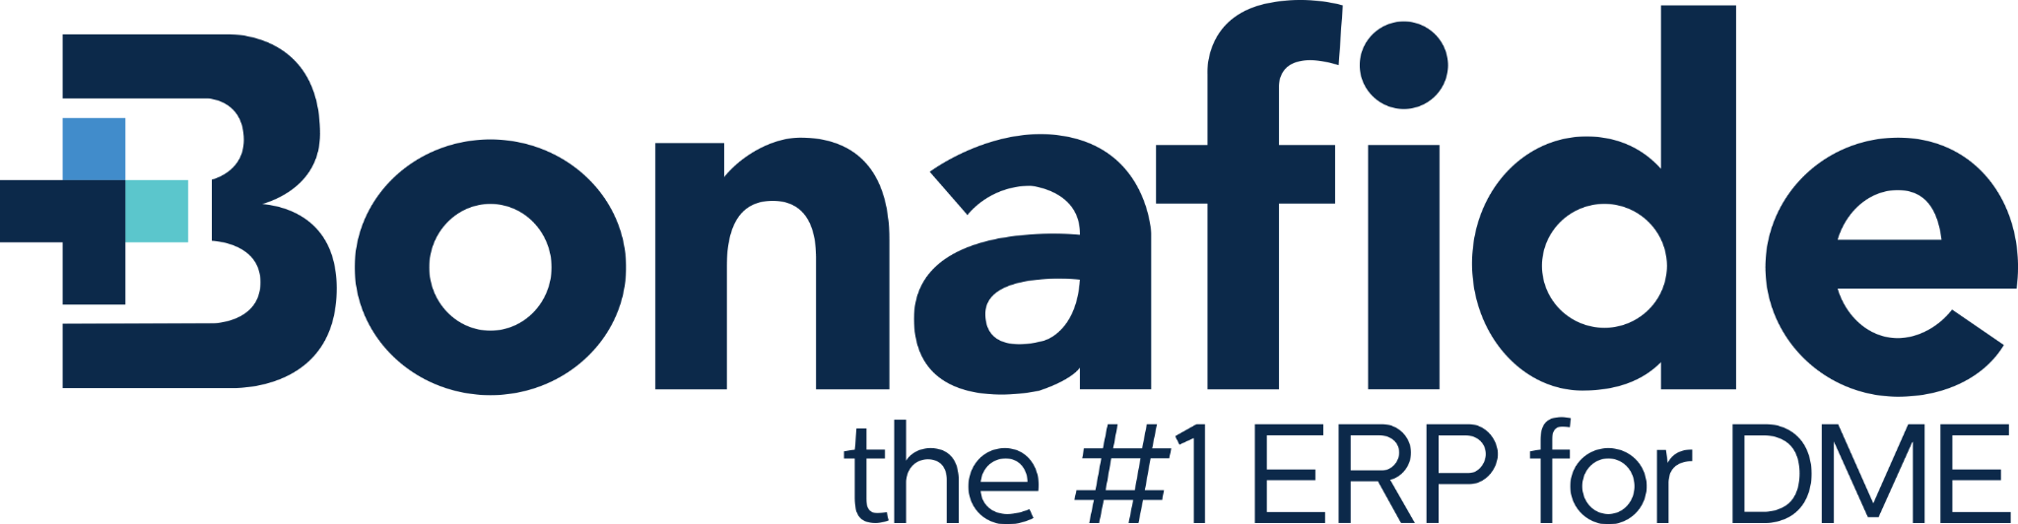
Customer: Bonafide Medical
Geography: SMB SouthWest
Industry: Healthcare
Multi-year: No
Competitive: Yes
Reference Status: Not a public reference
Use Case: AI/ML, Containers, DevOps
AWS Categories and Services: Managed Services
Partner: Mission Cloud
Partner Competency: Healthcare, Life Sciences
ProServe Involved: No

Customer Profile
Bonafide Medical Group combines its powerful DME and HME ERP software with a healthcare facility portal and other products to serve the Durable Medical Equipment (DME) and Medical Home Equipment (HME), Acute Care, and Long Term Care (LTC) healthcare settings.

The Opportunity
Bonafide Medical was looking for a one stop shop to support a number of initiatives related to AWS. Bonafide Medical wanted a partner to step in as a 24/7 NOC and SOC, extend the velocity of their Development team and accelerate multiple initiatives they have planned for the next three years. Mission Cloud was able to distinguish ourselves from a few other partners in a very competitive bid to help them with all of these initiatives.

The Solution
Mission Cloud now provides Bonafide Medical with peace of mind from our Cloud One managed service to service as the NOC and SOC assisting in the ongoing management of their various medical compliance frameworks they must adhere to.

Partner Solution
Mission Cloud now provides Bonafide Medical with peace of mind from our Cloud One managed service to service as the NOC and SOC assisting in the ongoing management of their various medical compliance frameworks they must adhere to. Additionally, Missions’ professional service team is engaged in assessing a variety of modernization and migrations that we will also support Bonafide with over the next two years.

How We Won
Having a focused partner, with all the necessary expertise on AWS, that could cover all their initiatives over the next three years was a big differentiator for Mission. Having presales resources and case studies speak to all the work that needed to be done, brought tremendous confidence to Bonafide that this was a partner that they could build a lasting partnership with and get all the support that they needed.

Account Team
Nick Wysocki - AE
Ben Hundley - SA

Special Thanks
Special thanks to Greg Lyons, for providing thorough background information on the scope of the opportunity for Mission, and as well prepping the customer on who Mission Cloud is. Greg is tremendous to work with and both Mission and our customers appreciate your support!

